Final Project: Pick a Project
Computer Science - Week 10
Oct 3, 2026 - Version 0.0.2
Please make sure to your UD email AND name is below. Unless your UD emails are included in this table, then you will not earn any points for this assignment when it is graded! Every person should submit their own individual worksheet.

Talk about each of the questions with a friend or our LLM (or both), but make sure the words you enter below are yours (with the obvious exceptions notwithstanding). Brainstorming is best done in full sentences, and the main goal here is brainstorming. It's worth reviewing the information in this series of pages in the Drafter documentation to gain a better understanding of the process.

Role | Name | Email
Developer (You) | Souritra Bhattacharjee | souritra@udel.edu
Friend (optional) | Kate Riker | rikerk@udel.edu

Part 1: The Goal & Prior Implementations
- Identify the Goal: What specific goal are you trying to address? Think about your passions, hobbies, and academic interests. The latter are an excellent candidate to focus on. Some majors have suggestions listed below: these were provided by faculty in those departments. Other majors could consider a focus tied to a big final assignment in one of their recent courses in their major.
  - Majors in the Electric & Computer Engineering department may consider a steganography project that hides messages in images, and then retrieves those messages.
  - Biomedical Engineering majors may consider one of the following:
    - If you have started (or completed) the Cell/Tissue Design final project in BMEG100, design an organoid, which involves combining a cell type, biomaterial, and testing method. Have the website include a description and diagram of your design concept, a testing method, a needs statement, and an impact statement relevant to their organoid. Also include a link to a paper that supports your idea and a paragraph describing how that paper supports your design concept.
    - Otherwise, create a website related to your BMEG100 Lab Report 1, Cytoskeletal and Nuclear Staining Lab Report Guidelines, linked here (University of Delaware account required to access).
  - Chemistry and Chemical Engineering majors may consider the project below.
    - Create an automated chemistry assistant that takes balanced reaction equations, starting reactant masses, and a harvested product amount to determine the limiting reactant, theoretical yield, and percent yield based on principles from Chemistry 2e (OpenStax) — Chapter 4: Chemical Reactions and Stoichiometry. To avoid manually compiling atomic mass tables or writing custom string tokenizers, use the chempy library to parse molecular formulas into exact molecular weights and verify reaction stoichiometry against compound data from the NIH PubChem Database. The program outputs an organized breakdown of limiting reagent status, product yields, and remaining masses of unreacted species. Also use the heat of the reaction to determine if it is exothermic or endothermic, and compute the heat flow per mole of the product.
I want my project to optimize routes for road trips. My website will be a road trip planner that identifies the most efficient path given a set of destinations using Traveling Salesman algorithms and then outputs the best trip options with their associated costs. In this way, it works toward the goal of fuel and time efficiency.

- Prior Implementations: Search the internet. What existing tools or websites currently attempt to address it?
There are two types of tools that help with route planning. The first one is maps, including Google Maps and RoutePlanner, which allow users to visualize a route and provide directions. The second type of tools are algorithmic optimizers, such as Mapquest and Optimoroute.com. However, a lot of these optimizers are paid and geared toward commercial use, not personal use. Most free tools don’t optimize road trips and provide cost estimations, which is what I aim to do.

- Your Implementation: Briefly describe the legitimate purpose or functionality of your site. How would you want this web application to be used?
My web application will be used to first identify the best route around a set of destinations, and then provide cost estimations of the trip. In other words, users will use it for the purpose of creating more efficient road trips and planning an appropriate budget.

Part 2: The Input-Process-Output (IPO) Model
Think about the fundamental flow of your program.
- The Core Goal: Every program has three main phases: taking input, processing data, and presenting output. In one sentence, what is the ultimate goal your program will accomplish for the user? Be specific and use CS1 concepts.
The ultimate goal of my program is to, given a set of locations, loop through all potential ways to travel those locations and then produce the best route, and also estimate the cost required for that road trip.

- Input: What specific information will the user need to provide to your program? (e.g., a city name, a numerical budget, a list of hobbies).
- The coordinates of the start point (home) and all travel destinations on the trip - (x,y)
- Fuel efficiency of user’s vehicle (mpg)
- Length of total trip (days)
- Number of travelers
- How much user is willing to spend on food - (1-5 scale)
- How much user is willing to spend on housing - (1-5 scale)

- Processing: At a high level, how will the computer manipulate or evaluate that data? (e.g., calculate the average, filter out options that are too expensive, compare the input against a database).
- The computer will loop through all the ways to cover each travel destination and produce the best route (shortest distance)
- This distance will be used to estimate the total toll price on the road
- The distance will be divided by the vehicle’s fuel efficiency to calculate total fuel use
- Total fuel will be divided by gas price (global constant) to estimate gas price
- Length of total trip (days) will be multiplied by a preset parking price (global constant) to estimate total parking price
- Users’ response on the food/housing scales and total length of trip would be multiplied by global constants to estimate food/housing costs

- Output: What will the user get back? (e.g., a recommendation, a calculated safety factor, a formatted schedule).
- A recommended route that will start from home, reach every destination on the trip, and return home
- The total estimated cost of the trip - broken down into fuel, tolls, parking, food, and housing

Part 3: Data Abstraction
Identify the "nouns" of your problem.
- Representing Reality: Abstraction is the process of representing the real world inside a computer by ignoring unnecessary details. What are the core "things" (nouns) your program needs to track? (e.g., If building a recipe app, the nouns are "Recipe" and "Ingredient").
Locations (coordinates), fuel, distance, cost, food/housing expense rating

- Identifying Properties: For the most important "thing" you listed above, what 3 to 4 specific details do you actually need to solve your problem, and what details will you abstract away?
  - Details I need: (e.g., Ingredient name, weight, cost)
  - Details I will ignore: (e.g., Ingredient color, brand, expiration date)
For fuel, specific details I need include a gas price (global constant), fuel efficiency of vehicle, and total distance. I will ignore everything else about the vehicle, including brand, year, type and the trip, including other costs.

Part 4: Challenges, AI Strategy, & Goals
- Difficulties: What parts of this project seem the most difficult or technically complex?
The most technically challenging part I believe is to loop through every possible route and find the shortest one. There are many algorithms to do this, formally known as the Traveling Salesman Problem in applied mathematics, but the best option is to literally brute force through every possible route and find the minimum distance.

- Coding Strategy: If you will be using an LLM to help code, how will you ensure you understand the generated code and avoid "hallucinations" or "shallow learning" (copying without understanding)? If you won't be using an LLM to help code, this project might take about 4 hours a week to complete, so list each of the days and times in which you work on the project.
For my project, I will be relying a lot on unit testing, as well as simply running the website, to ensure that the code generated by LLMs is working properly. I will also prompt the LLM to document important sections of the code and explain the algorithmic choices made. This will be especially necessary for the global constants, such as gas price and daily parking price, as I need to understand why the AI is using a particular numeric value and whether I need to authorize global constants myself. Avoiding “shallow learning” is a bigger issue, but I will be the one facilitating all the mathematical calculations, not the AI. Moreover, this project is something I am mathematically able to do on pen-and-paper; the LLM is merely helping me make it a web app. So shallow learning won’t be a huge problem.

- Goals: What is your ultimate goal for this project? (e.g., Impress the graders with a creative UI, build something I can use in my other classes, learn Drafter deeply).
The ultimate goal for my project is to reduce fuel usage and thus contribute to a more sustainable world, as well as to demonstrate the applications of the Traveling Salesman Problem - one of my favorite heuristic math problems that I aim to study in grad school.

Part 5: Research & Brainstorming Conversation
Have a conversation with a Generative AI tool (like ChatGPT or Claude) OR a friend about your project idea. Do not ask for code. Instead, use the AI/friend as a sounding board to research your problem.
- The Initial Prompt/Question: Ask the AI or your friend to help you brainstorm. (e.g., "I want to build a simple web tool to help students track their study hours. What are 3 common problems students face when tracking their time, and what are 3 simple features a basic tool should have?"). Paste your prompt below:
I want to build a web tool to optimize multi-stop routes and produce the best route along with its estimated cost. What variables should I consider in my final cost estimation and should I use brute force to find the best route?

- The Response: Briefly summarize the best ideas the AI or your friend suggested. What existing solutions or prior apps did they mention?
The LLM and my friend Kate both suggested that my trip cost estimation should include fuel, parking cost, food/housing, and tolls. For small trips, up till 7-8 stops, the LLM recommended using brute force, as it is feasible computationally to calculate each possible route and output the best one. Unlike other algorithms, this will always give the most efficient route. An interesting point brought up by the AI was to assign a labor cost for driving, but I will probably ignore this because my trip planner is intended for personal vehicle use, not commercial. Existing apps mentioned include Google maps, MapQuest, fleet route optimizers (commercial) and booking apps.

- The Pushback: You must reply to the AI/friend to narrow the scope when it's over-ambitious. Pick the most complex feature they suggested and explain why it is too complicated for an introductory programming project. Ask them for a simpler alternative. Paste your response here:
I think comparing the efficiency of different routes against the original trip order is a little too complex, as it would double the computations needed. What is a simpler alternative to this?

- Reflection: Based on this conversation, how has your project idea changed or become more focused?
My project’s output has now become more focused as I know exactly what my web app should produce - the best route and the cost of the trip. I also have a better idea of what variables I should include in the cost estimation of the trip, as well as which algorithm to use for finding the best route given coordinates of locations.

Part 6: Resource Planning
- What resources will you use if you get stuck?
- Understand how existing websites that do a similar job work
- Refer to the project requirements if I want to simplify it
- Talk to friends and adults for help
- Use LLMs to identify and fix problems
- Sketch an outline of what I want the app to do, so I can identify the errors

- If your LLM provides code that causes a Drafter or Bakery error, or if you run into a problem during deployment, what is your step-by-step debugging plan to resolve it?
- Check that all libraries are updated
- Read the error message carefully and understand it
- Make changes to the code where errors were traced
- Ask the LLM to explain the error
- Reach out to my professor or TA
- If the problem is still unsolvable, modify the scope of the project or use different libraries/tools

Part 7: LLM Conversation
If you used an LLM in any part of this work, copy and paste every part of that conversation below. Otherwise, you may be given a zero for the assignment. Obviously, these words will not all be yours, and this is the exception to the requirement at the top of this assignment that all responses be in your own words. If you did not use an LLM to assist you in this assignment, simply say so below.
Give me ideas for this Drafter project that apply mathematical methods to real-world scenarios (must be complex enough)
For your Drafter CS1 project, I’d look for ideas where math helps someone make a real-world decision rather than just calculating an answer. The best projects take information from a user, process it mathematically, and produce a useful recommendation, comparison, or prediction.
Here are 12 ideas across different areas, with a focus on projects you can realistically build in three weeks using Python.

12 real-world applied mathematics website ideas
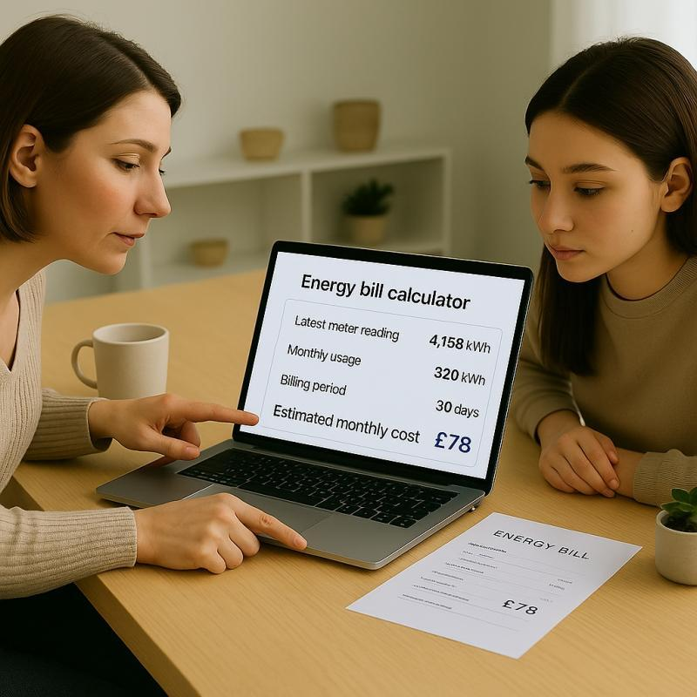

1. EnergyWise — Home energy cost estimator
Real-world problem: People don't know which appliances contribute most to their electricity bills.
- Math: Multiplication, unit conversion, rates.
- Input: Appliance wattage, hours used per day, electricity price.
- Processing: Calculate kilowatt-hours consumed and estimated cost.
- Output: Monthly energy costs and a ranking of the most expensive appliances.
Example: Compare the cost of running a space heater for 2 versus 6 hours daily.
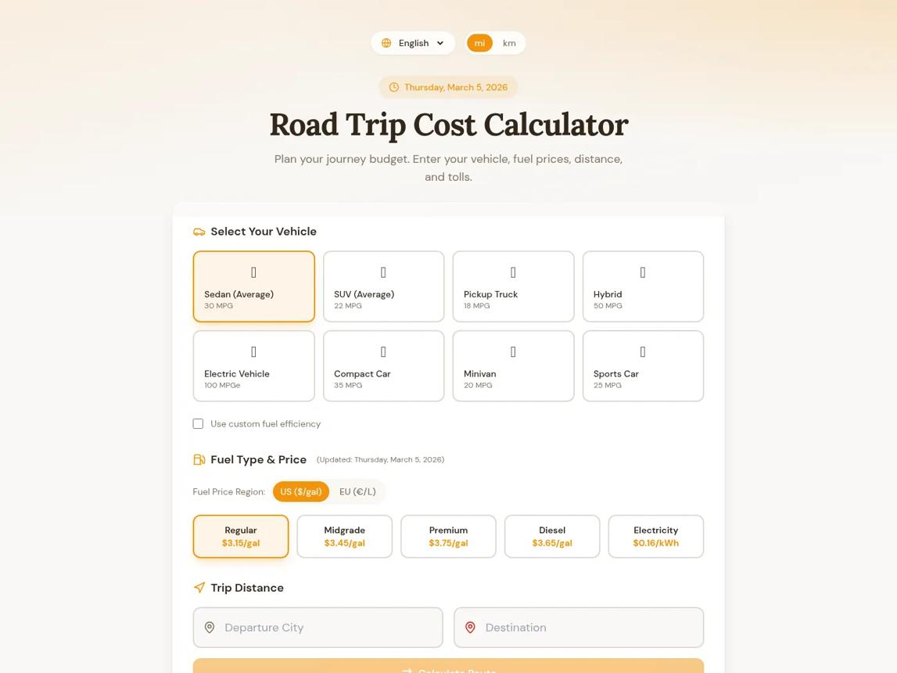

2. TripWise — Road trip cost planner
Real-world problem: Travelers underestimate the cost of driving somewhere.
- Math: Distance, rates, ratios, and addition.
- Input: Distance, fuel efficiency, gas price, tolls, number of travelers.
- Processing: Estimate fuel consumption and total trip cost.
- Output: Total cost and cost per person.
Example: Compare the estimated cost of driving alone versus splitting expenses among four people.
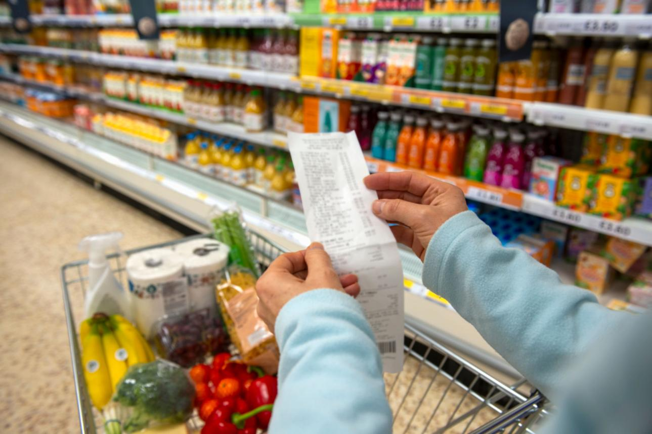

3. PriceSmart — Grocery value calculator
Real-world problem: Shoppers struggle to identify the best value when packages have different sizes and prices.
- Math: Ratios, unit rates, percentages.
- Input: Product prices and quantities.
- Processing: Calculate cost per ounce, pound, or item.
- Output: Best-value option and potential savings.
Example: Determine whether a 24-ounce package is a better deal than two 10-ounce packages.


4. GoalGetter — Savings goal planner
Real-world problem: People don't know how much to save each week to afford a purchase.
- Math: Rates, percentages, and projections.
- Input: Target cost, current savings, deadline.
- Processing: Calculate the amount needed per week or month.
- Output: A savings schedule and progress chart.
Example: Find out how much to save every payday to afford a laptop in five months.
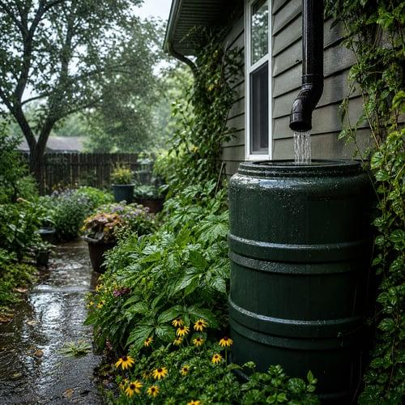

5. RainSmart — Rainwater collection calculator
Real-world problem: Homeowners want to know how much rainwater they could collect for gardening.
- Math: Area, volume, unit conversions.
- Input: Roof area, rainfall amount, collection efficiency.
- Processing: Estimate collected water using roof area × rainfall depth × efficiency.
- Output: Liters or gallons collected per rainfall event and potential water savings.
Example: Estimate how much water a rain barrel could collect from a one-inch rainfall.


6. SpacePlanner — Room layout calculator
Real-world problem: People buy furniture that doesn't fit their rooms.
- Math: Area, geometry, percentages.
- Input: Room dimensions and furniture dimensions.
- Processing: Calculate floor area used and remaining space.
- Output: Percentage of floor space occupied and a simple layout feasibility check.
Example: Determine whether a bed, desk, and dresser fit within a dorm room's dimensions.
Scope tip: Start with dimensions and area calculations rather than building a full drag-and-drop 3D design tool.
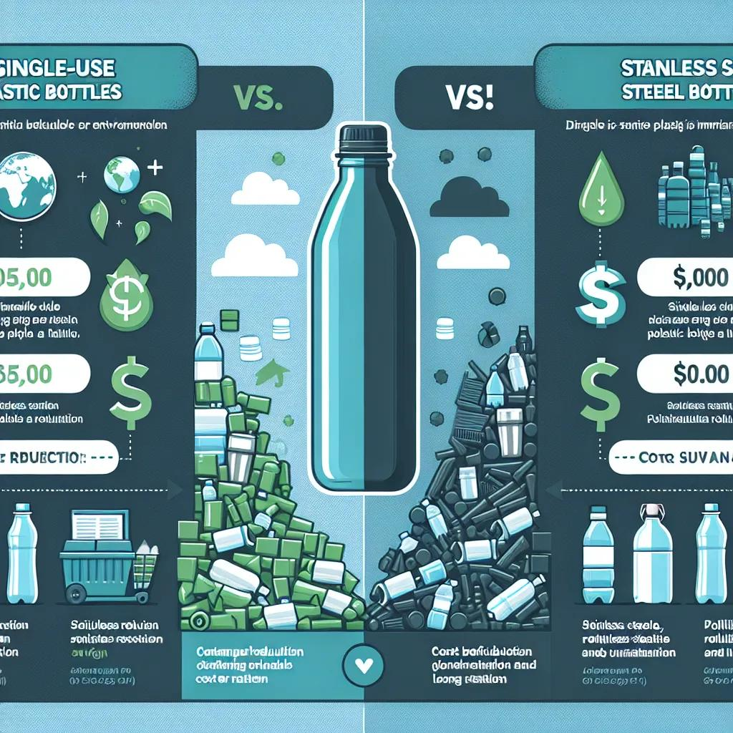

7. WasteLess — Waste reduction estimator
Real-world problem: People want to understand how much waste they could avoid by changing everyday habits.
- Math: Multiplication, averages, percentages.
- Input: Disposable items used per day and reusable alternatives.
- Processing: Project annual item use and potential reductions.
- Output: Estimated items avoided over a month or year.
Example: Calculate how many disposable cups could be avoided by using a reusable cup four days a week.
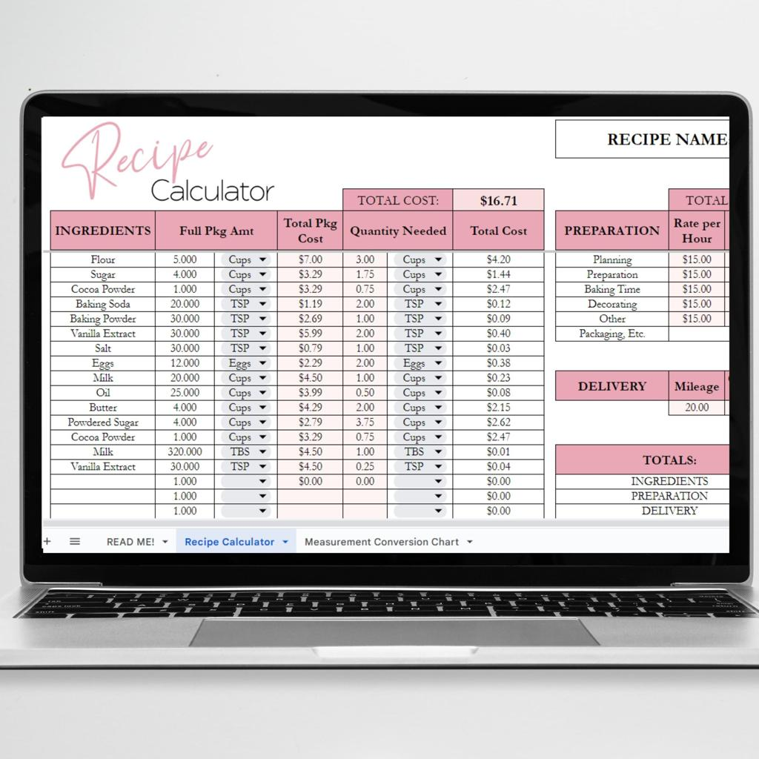

8. SmallBiz Math — Small business profit calculator
Real-world problem: Small sellers don't know how to price products to cover their costs.
- Math: Revenue, profit margins, percentages, break-even analysis.
- Input: Material costs, labor costs, selling price, fixed expenses.
- Processing: Calculate profit per item and break-even sales volume.
- Output: Recommended minimum price for a user-selected profit target and number of sales needed to cover expenses.
Example: Help a student selling baked goods determine how many items they need to sell to break even.


9. PacePredict — Race time estimator
Real-world problem: Runners want to estimate finish times at different distances.
- Math: Rates, ratios, averages.
- Input: Distance completed and time taken.
- Processing: Calculate pace and extrapolate a finish time.
- Output: Estimated finish times for different distances.
Example: Estimate a 5K finish time from a runner's recorded pace, noting that actual pace may change with distance.


10. CommuteCalc — Commute comparison tool
Real-world problem: Commuters want to compare travel options by time and cost.
- Math: Rates, time calculations, totals.
- Input: Travel duration, cost per trip, commuting days.
- Processing: Calculate weekly and monthly totals for each option.
- Output: Cheapest option, fastest option, and the time or money saved.
Example: Compare driving with taking a bus using user-entered estimates rather than relying on live transit data.


11. GardenGrid — Garden planting planner
Real-world problem: Gardeners want to know how many plants fit in a garden bed.
- Math: Area, spacing, multiplication, division.
- Input: Garden dimensions and spacing requirements for plants.
- Processing: Estimate how many rows and plants fit.
- Output: Plant capacity and a simple grid layout.
Example: Calculate how many tomato plants fit in a 4-by-8-foot raised bed when each plant needs a specified spacing.
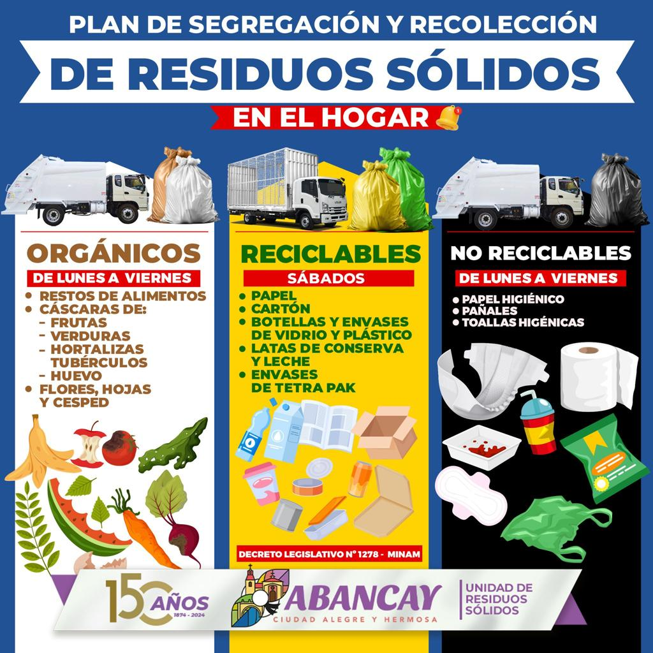

12. SortSmart — Recycling impact calculator
Real-world problem: Households want to estimate how much waste they recycle instead of throwing away.
- Math: Percentages, totals, averages.
- Input: Estimated amounts of waste and recyclable materials.
- Processing: Calculate recycling rates and compare weekly totals.
- Output: Recycling percentage and projected monthly waste reduction.
Example: Show how increasing the share of properly recycled waste changes a household's estimated landfill contribution.

My top 4 recommendations
These offer a good balance of real-world usefulness, mathematical depth, and manageable implementation.
TripWise — Road trip cost planner
Best overall
It solves a recognizable problem, supports several input variables, and makes it easy to compare scenarios with a chart.
SmallBiz Math — Profit calculator
Best for deeper mathematical reasoning
Break-even analysis gives the project a meaningful purpose beyond simple arithmetic.
EnergyWise — Energy estimator
Best for data visualization
You can calculate energy consumption for multiple appliances and visualize the biggest contributors to a bill.
PriceSmart — Grocery value calculator
Best for a simple but useful application
Unit-price comparisons are easy to implement, test, and explain during a project demonstration.

What makes one of these a good CS1 project?
For your Drafter application, a strong first version should have:
- Input: Several values entered by the user.
- Processing: A meaningful mathematical formula or algorithm.
- Output: A recommendation, comparison, prediction, or graph.
- Data abstraction: A structured representation of the things your app tracks, such as trips, appliances, or products.
- Scope control: A small dataset and no need for accounts, a backend, or a complex live-data integration.
You can also save user-entered records in browser local storage so the website remembers previous calculations.
My advice: Pick the idea where the output helps someone make a decision, not just see a number. TripWise, SmallBiz Math, and EnergyWise are particularly good starting points. The next step would be to choose one and map its inputs, mathematical processing, outputs, and data structures to your project worksheet.

For CS1 applied-math projects, Replit can help turn ideas into apps.
I like the trip wise idea. my website should have 2 parts: 1) a route optimizer - i use traveling salesman algorithms to find the shortest possible distance for the trip and 2) trip cost planner
I think this is a really strong direction for your CS1 project. TripWise would combine two distinct applications of mathematics: optimization algorithms and financial calculations. That gives your website more depth than a standard trip calculator while still being feasible to build in Drafter.

TripWise: Smart Road Trip Planner
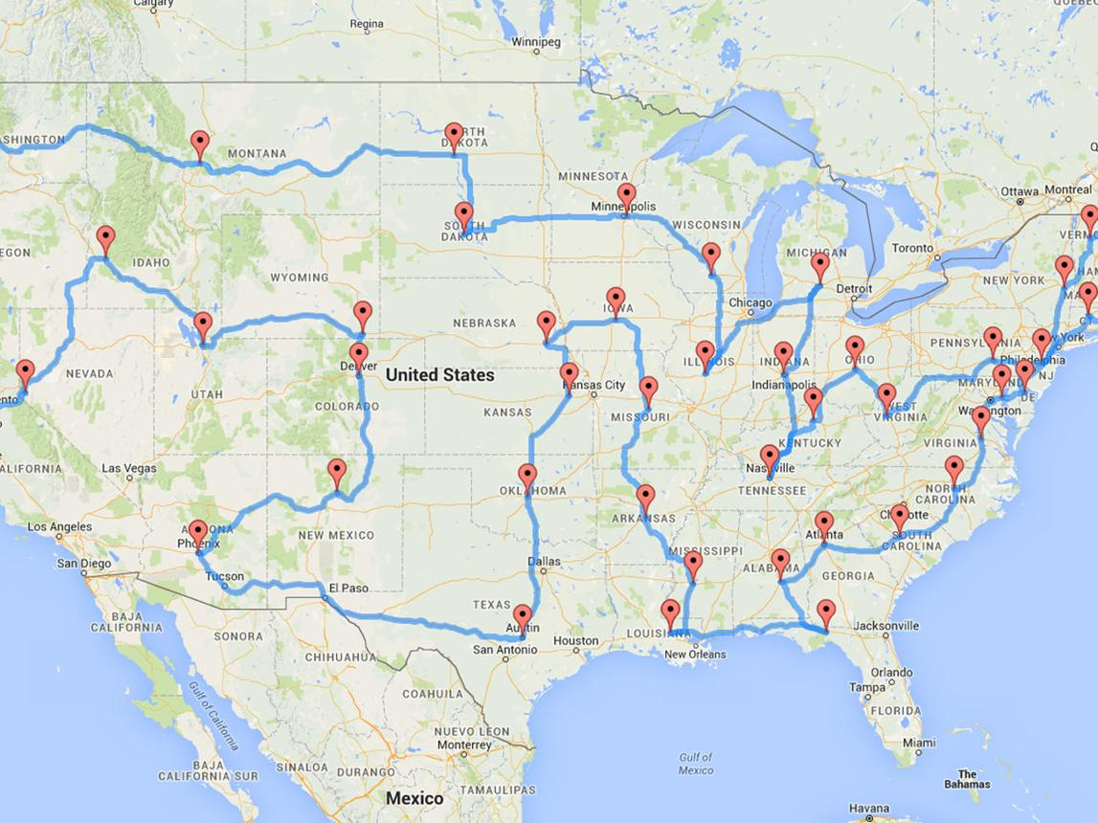
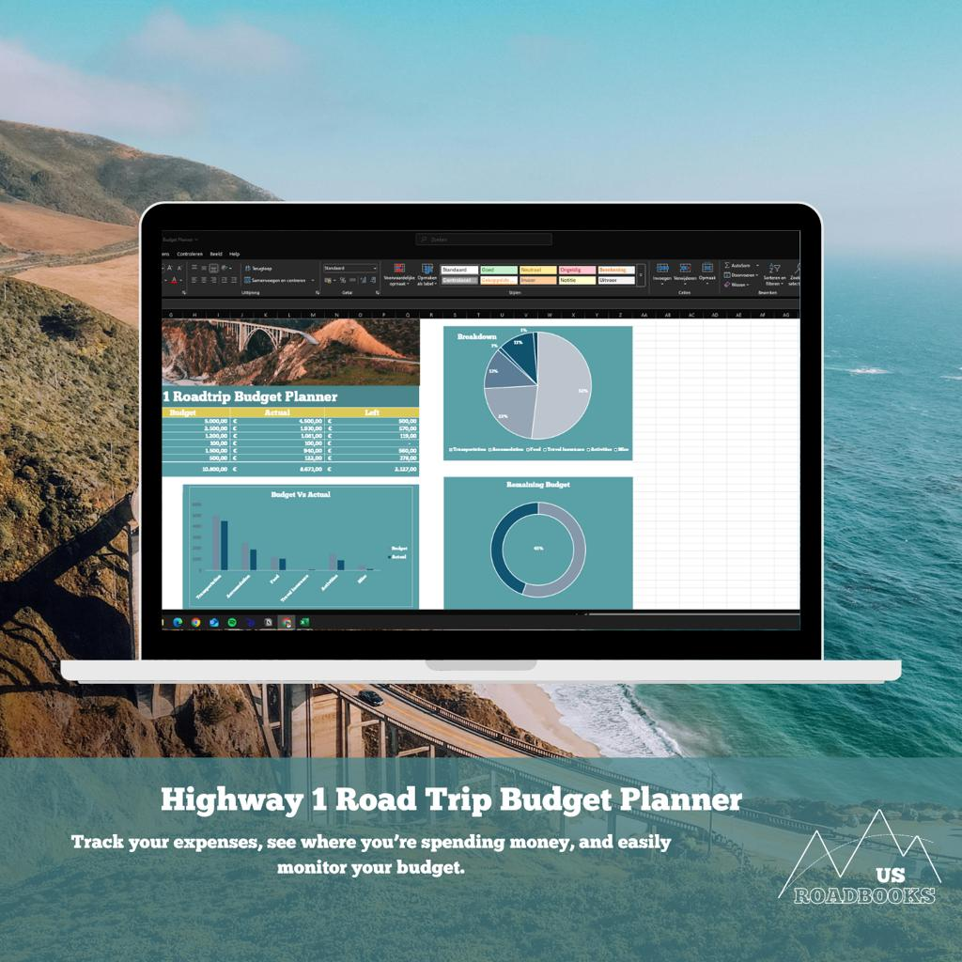
The website would have two main sections that work together but can also be used independently.

Part 1: Route Optimizer
Goal: Find an efficient order for visiting multiple destinations while minimizing the total distance traveled.
Imagine a student planning a road trip from the University of Delaware to several destinations. Instead of manually deciding which destination to visit first, TripWise calculates a better route.

How it works
1. Input destinations
The user enters a starting location and a list of destinations to visit.
2. Calculate distances
Represent each location as a node and the distance between locations as an edge in a weighted graph.
3. Optimize the route
Use a Traveling Salesperson Problem (TSP) algorithm to find a short route visiting every destination.
4. Display the result
Show the recommended visit order, total distance, and optionally compare it with the original route.

Which algorithm should you use?
For a three-week CS1 project, I'd recommend starting with a nearest-neighbor algorithm, which is a simple heuristic for the TSP.
At each step, the algorithm visits the closest unvisited destination.
For example, imagine these destinations:
- Start: Newark, Delaware
- Destination A: Philadelphia
- Destination B: Baltimore
- Destination C: Washington, DC
The algorithm repeatedly selects the closest destination that hasn't been visited yet, then adds up the distances along the route.
Important mathematical distinction: Nearest neighbor does not guarantee the shortest possible route. It finds a reasonable route quickly. If you want to guarantee the optimal solution, you could use brute force for a very small number of destinations, such as five or six, by comparing every possible visiting order.
For your project, you could even compare the two algorithms and show how much distance the heuristic saves relative to a user's original route.

A realistic technical limitation
The algorithm needs a distance between each pair of locations. You have two manageable options:
- Simpler: Let users enter a distance matrix themselves, or provide a small predefined set of destinations and distances.
- More ambitious: Obtain real road distances from a routing service.
Straight-line distances between geographic coordinates are easier to calculate, but they aren't the same as driving distances. Also, finding an efficient order using road distances does not automatically produce turn-by-turn directions.
I'd start with a distance matrix so that the optimization algorithm is entirely under your control.

Part 2: Trip Cost Planner
Goal: Estimate the total cost of a trip and determine how much each traveler should contribute.
This section takes the distance from the route optimizer and uses it to calculate estimated expenses.

Example trip cost breakdown
Illustrative values for a hypothetical trip
Fuel
500 miles, 25 MPG, $3.50/gallon

$70.00
Tolls
User-entered estimate

$20.00
Accommodation
User-entered total

$80.00
Total trip cost

$170.00
Cost per person (4 travelers)

$42.50

Mathematical calculations
Your program would calculate fuel cost using:
Fuel cost=DistanceMPG×Price per gallon
Fuel cost=
MPG
Distance
​
×Price per gallon
Then calculate the total cost:
C=F+T+H+P+O
C=F+T+H+P+O
Where:
- F
- F = fuel cost
- T
- T = tolls
- H
- H = accommodation
- P
- P = parking
- O
- O = other expenses
Finally:
Cost per person=CN
Cost per person=
N
C
​
Here,
N
N is the number of travelers splitting the expenses equally.

Additional features you could include
- Compare the cost of two different routes.
- Add a food budget and hotel expenses.
- Compare fuel-efficient and less fuel-efficient vehicles.
- Calculate each person's contribution.
- Show a chart of which expenses account for the largest share of the budget.
I'd make these optional extras rather than requirements for the first version.

How the two sections connect

User enters destinations
Locations and distances

Route optimization
Choose a visiting order and calculate distance

Trip cost calculation
Use the optimized distance to estimate fuel cost

Final trip report
Recommended route, distance, total expenses, and cost per traveler

Is this realistic for a three-week CS1 project?
Yes, if you limit the first version to a small number of destinations and manually supplied distances.
Feature | Priority | Difficulty
Enter destinations and distances | Essential | Easy
Nearest-neighbor route algorithm | Essential | Medium
Fuel and total cost calculator | Essential | Easy
Cost per traveler | Essential | Easy
Compare optimized route with original order | Recommended | Medium
Interactive map with real driving routes | Optional | Hard
Live gas prices and hotel prices | Skip initially | Hard
You can implement both sections using basic Python functions, lists, dictionaries, loops, and arithmetic. Drafter can handle the interface, and browser local storage can optionally remember previous trips. You won't need a backend or database.
One subtle but important detail: if your route optimizer uses a fixed starting location and requires returning to that location at the end, your algorithm must account for that return distance. You should decide early whether trips are round trips or one-way journeys.
My recommended next step: Define your route optimizer's exact rules — number of stops, whether the trip returns to the start, and how distances are obtained. Once those are fixed, the rest of the project becomes much easier to plan.

Part 8: Submit
In Google docs, with this document open, please click on File > Download > Microsoft Word (.docx), and make sure you put that download somewhere you can find it again. Then, upload it to the Canvas assignment about selecting or brainstorming your final project.

When you're done with this assignment, review this page of the Drafter documentation to better prepare for the next step.

